Seaside Level Prop List

Sub-Zone – Warf

Level Generic
- Fire hydrants

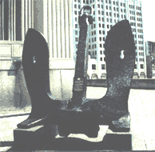
Sub-Zone Specific

-Large anchor as a “sculpture” on street corner
-Seagulls circling (multiple rotating planes with seagull texture on it)
-Crane
-Kites
-Tankers/freighters
-Freighter containers
-Trolleys (ala San Fran, maybe as an AI car)
-Boardwalk texture
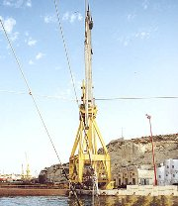
-Steep hill sign
-Lighthouse
-Wharf sign (change the text to say squidport)
-Hot pants crates
-Every 3rd store is a kite store
-Every 4th store is a seafood store
- warf lamp
- sp lamp
- sp garbage
- sp tree guard
- sp bench
- poted tree
- sp sign
- anchor
- quaye
- wharehouse gen set
- crates
- containers
- barrel
- box
- life ring
- orange buoys
- channel marker (water)
- street lamps with banners
- loading crane
- olde towne traffic sign
- large fish, scale
- fish stand
- tele poles
- bushes
- firehy
- municiple lamp for hills (on file)

